**EXERCISE 4**

1) Use the cat command to create a file containing the following data. Call it myfile

use tabs to separate the fields.

1001 RAM 97

1025 ARUN 86

1013 RAJU 93

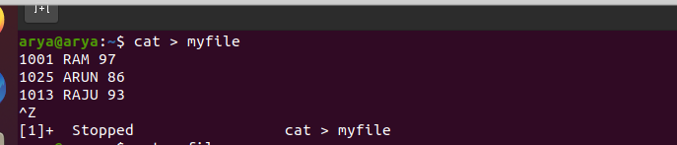



2) Use the cut and paste commands to swap fields 2 and 3 of myfile.



3) Print first 2 rows of the file myfile



4) Print the contents of 3rd row only of the file myfile



5) Print the names only from the file myfile

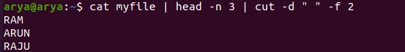

6) Count the number of Lines, words and characters from the previous output

